**Project Name:** IOT Smoke Detection System

**Github Link:** https://github.com/projectsforstudents2022/IOT_Smoke_Detection_System.git

**Why was this project created?**

For the protection of property and human life, fire detection is essential. Smoke and other fire byproducts are used as the primary means of detection in traditional fire detection methods. Ionization is used to identify the presence of particles produced by fire and smoke. The main limitation of conventional systems is their limited coverage due to the requirement that the sensors be placed close to the fire in order to detect it.

**What problem is it solving?**

The main goal of this deep learning-based computer vision-based fire detection system is to identify the fire and generate warning alerts if the fire is found. In comparison to conventional systems, the sum of the aforementioned hints creates a fire detection system that is more effective.

**Entire explanation of project**

* **PROPOSED APPROACH**

The dataset used to train the system consists of a collection of photos with fire in them; the fire section of the image is labeled to extract its feature, and the labeled image is utilized to train. There are 3000 fire-related photos with labels in RGB and jpg format. The whole dataset, which includes more than 3000 photos that were processed over 10 hours, can be used for the initial training. The weights defining the network topology are only updated when such an increase in validation loss takes place since an increase in the loss sustained during validation indicates an increase in the model's accuracy.

The tensor-flow deep learning framework is used to create the suggested CNN-based model, which is then run on an NVIDIA GeForce GTX 1080ti GPU. We set the weight-decay parameter to 0.0005 and the momentum parameter to 0.9. Initial learning is done at a rate of 0.001. The gamma value is set to 0.0001 and the power value is set to 0.75 for the learning rate update policy. 64 image patches (as positive and negative samples) are input for each iteration, and we set the batch size for training to 64. We received the trained CNN-based model with trained weights and parameters for testing after 20000 iterations.

Algorithm for creating next word prediction model :

**Step 1:** Import Libraries & Load Dataset

**Step 2:** Data Preprocessing

**Step 3:** Data Analysis

**Step 4:** Build Logistic Regression Classifier

**Step 5:** Train Model

**Step 6:** Testing & Visualization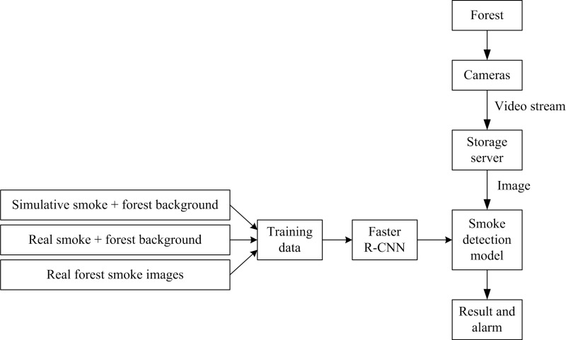

* **DATA FLOW DIAGRAM**
* **RESULT**

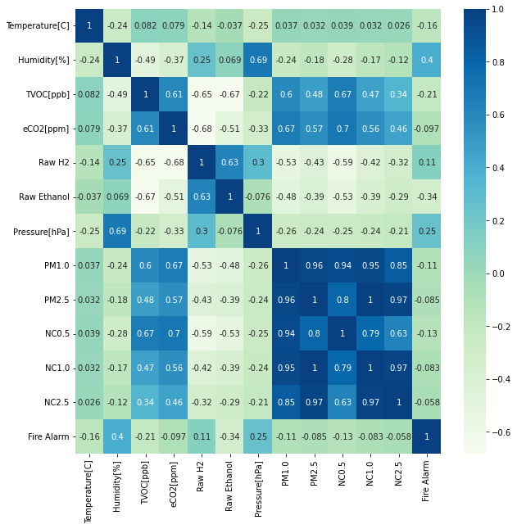

* **CONCLUSION**

Since deep learning-based detection systems identify the combustible itself rather than its byproducts like smoke, heat, etc., they have overcome the limits of conventional smoke and heat detectors. The following important features were noted once the system's functioning was practically validated. The beginning of the fire may be seen. This provides compelling evidence for its early ability to detect fire.